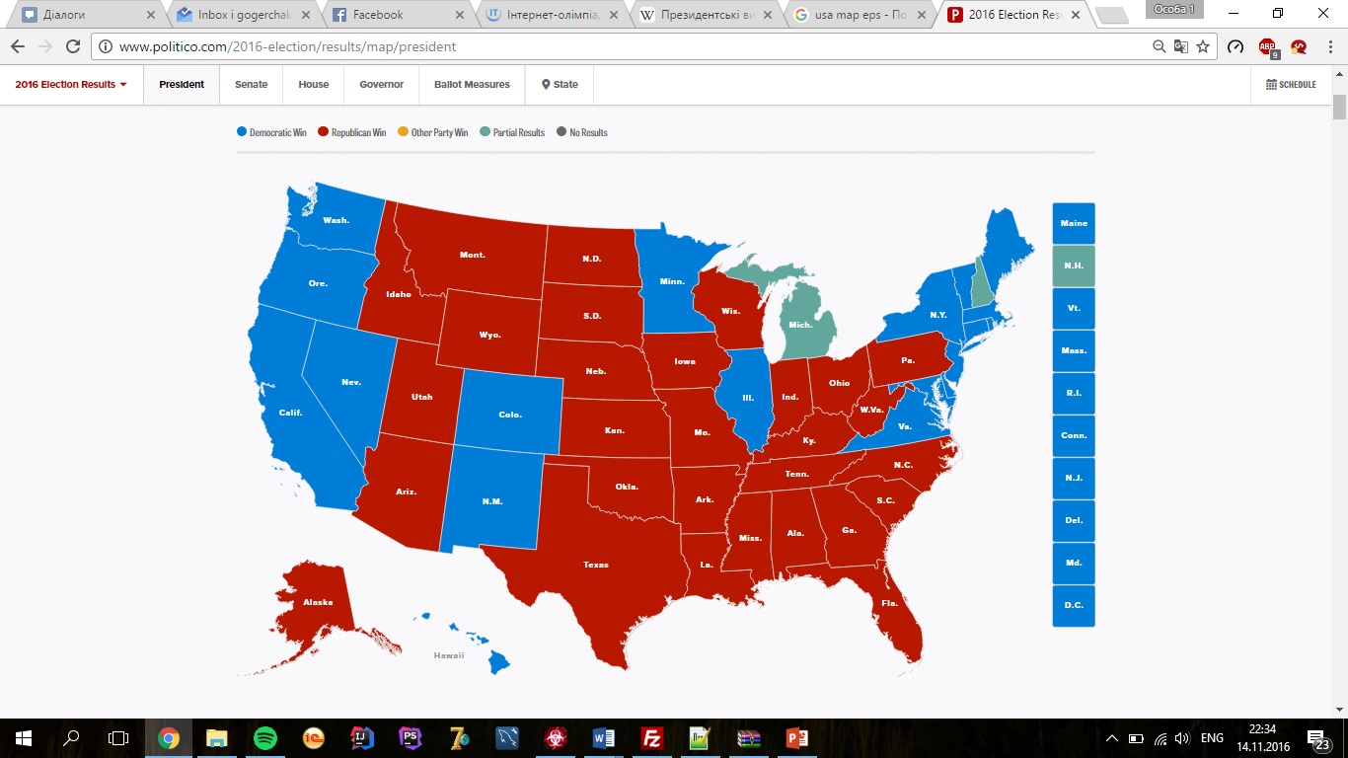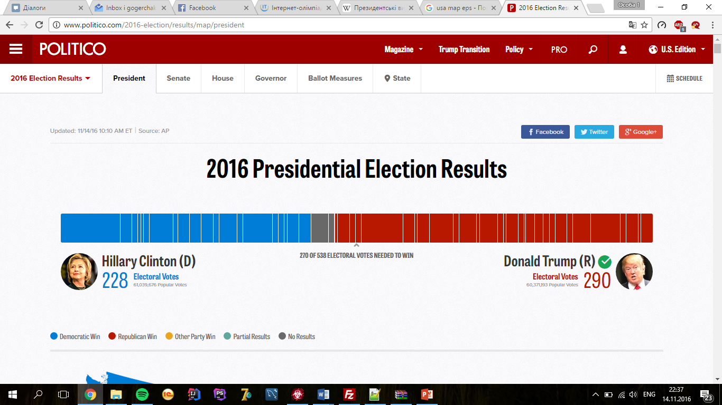

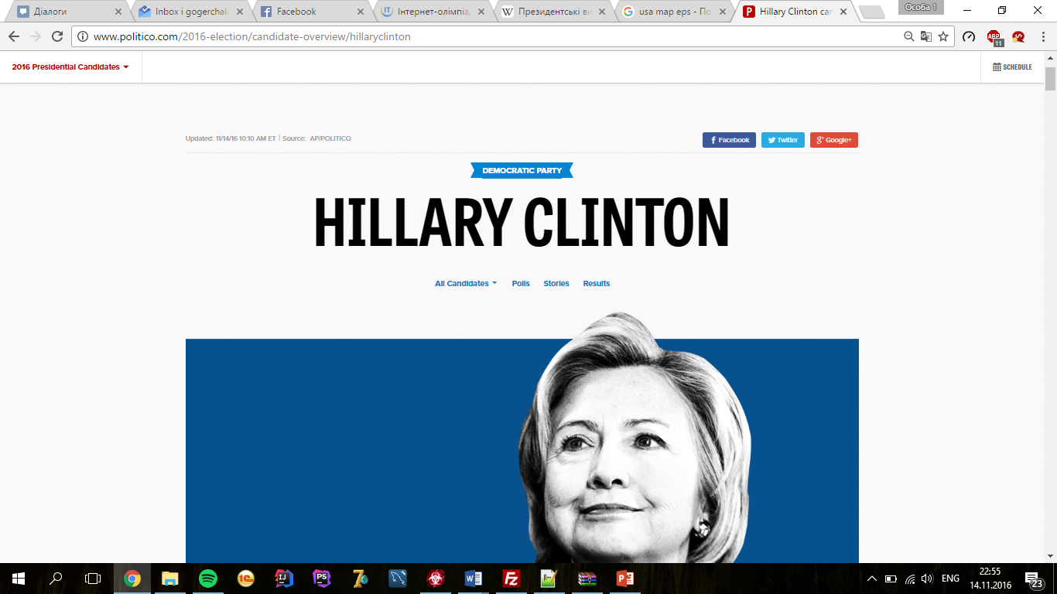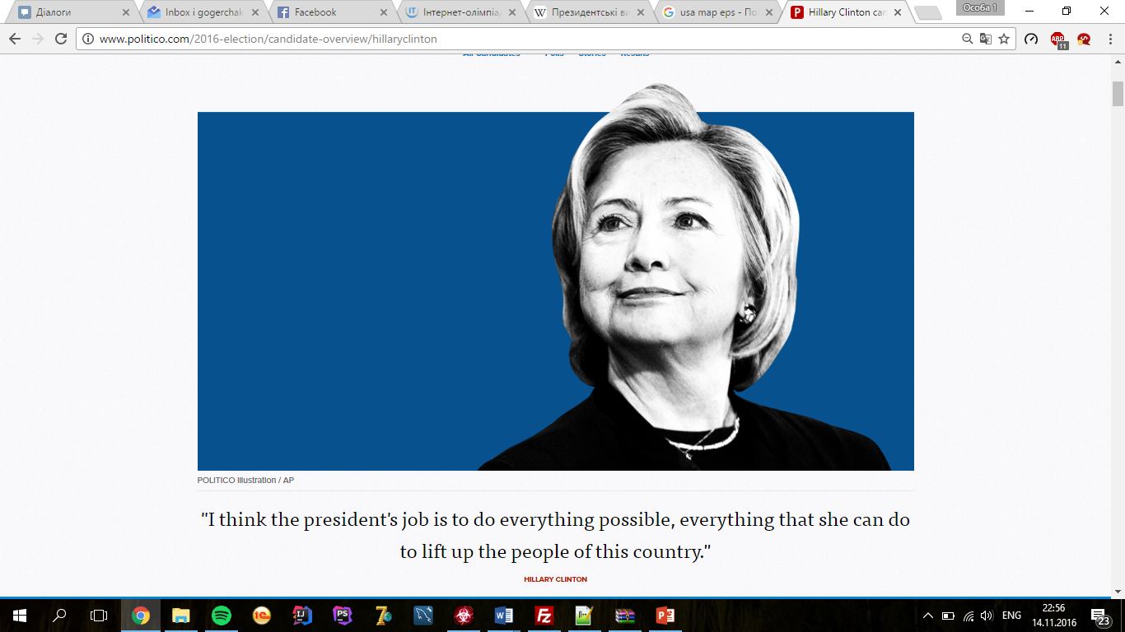





|  |  |  |  |  |  |  |  |  |  |  |  |  |  |  |  |  |
| --- | --- | --- | --- | --- | --- | --- | --- | --- | --- | --- | --- | --- | --- | --- | --- | --- |
|  | | **Hillary Clinton Democratic** | | | **Donald Trump Republican** | | | **Gary Johnson Libertarian** | | | **Jill Stein Green** | | | **Evan McMullin Independent** | | |
| **State or district** | **Electoral method** | **#** | **%** | **Electoral votes** | **#** | **%** | **Electoral votes** | **#** | **%** | **Electoral votes** | **#** | **%** | **Electoral votes** | **#** | **%** | **Electoral votes** | **#** |
| [Alabama](https://en.wikipedia.org/wiki/United_States_presidential_election_in_Alabama,_2016) | WTA | 718084 | 34.55% | – | 1306925 | 62.89% | 9 | 43869 | 2.11% | – | 9287 | 0.45% | – |  |  |  | AL |
| [Alaska](https://en.wikipedia.org/wiki/United_States_presidential_election_in_Alaska,_2016) | WTA | 93007 | 37.72% | – | 130415 | 52.89% | 3 | 14593 | 5.92% | – | 4445 | 1.80% | – |  |  |  | AK |
| [Arizona](https://en.wikipedia.org/wiki/United_States_presidential_election_in_Arizona,_2016) | WTA | 888374 | 45.32% | – | 972900 | 49.64% | 11 | 80151 | 3.83% | – | 23697 | 1.21% | – |  |  |  | AZ |
| [Arkansas](https://en.wikipedia.org/wiki/United_States_presidential_election_in_Arkansas,_2016) | WTA | 378632 | 33.65% | – | 681765 | 60.59% | 6 | 29518 | 2.63% | – | 9406 | 0.84% | – | 13180 | 1.17% | – | AR |
| [California](https://en.wikipedia.org/wiki/United_States_presidential_election_in_California,_2016) | WTA | 5488261 | 61.46% | 55 | 2969532 | 33.25% | – | 312369 | 3.16% | – | 152539 | 1.71% | – |  |  |  | CA |
| [Colorado](https://en.wikipedia.org/wiki/United_States_presidential_election_in_Colorado,_2016) | WTA | 1126384 | 46.91% | 9 | 1075770 | 44.80% | – | 129451 | 5.0% | – | 29299 | 1.22% | – | 24679 | 1.03% | – | CO |
| [Connecticut](https://en.wikipedia.org/wiki/United_States_presidential_election_in_Connecticut,_2016) | WTA | 823360 | 53.86% | 7 | 637919 | 41.73% | – | 48051 | 3.01% | – | 21539 | 1.41% | – | 1481 | 0.10% | – | CT |
| [Delaware](https://en.wikipedia.org/wiki/United_States_presidential_election_in_Delaware,_2016) | WTA | 235581 | 53.35% | 3 | 185103 | 41.92% | – | 14751 | 3.35% | – | 5865 | 1.38% | – |  |  |  | DE |
| [D.C.](https://en.wikipedia.org/wiki/United_States_presidential_election_in_the_District_of_Columbia,_2016) | WTA | 260223 | 90.54% | 3 | 11553 | 4.02% | – | 4501 | 1.57% | – | 3995 | 1.39% | – |  |  |  | DC |
| [Florida](https://en.wikipedia.org/wiki/United_States_presidential_election_in_Florida,_2016) | WTA | 4487657 | 47.79% | – | 4607146 | 49.06% | 29 | 206007 | 2.20% | – | 64060 | 0.68% | – |  |  |  | FL |
| [Georgia](https://en.wikipedia.org/wiki/United_States_presidential_election_in_Georgia,_2016) | WTA | 1856509 | 45.74% | – | 2078064 | 51.20% | 16 | 123641 | 3.10% | – |  |  | – |  |  |  | GA |
| [Hawaii](https://en.wikipedia.org/wiki/United_States_presidential_election_in_Hawaii,_2016) | WTA | 266827 | 60.98% | 4 | 128815 | 29.44% | – | 15949 | 3.70% | – | 12727 | 2.91% | – |  |  |  | HI |
| [Idaho](https://en.wikipedia.org/wiki/United_States_presidential_election_in_Idaho,_2016) | WTA | 190971 | 27.46% | – | 412525 | 59.32% | 4 | 28256 | 4.10% | – | 8524 | 1.23% | – | 46702 | 6.72% | – | ID |
| [Illinois](https://en.wikipedia.org/wiki/United_States_presidential_election_in_Illinois,_2016) | WTA | 2982415 | 55.41% | 20 | 2121573 | 39.41% | – | 204491 | 3.80% | – | 74026 | 1.38% | – |  |  |  | IL |
| [Indiana](https://en.wikipedia.org/wiki/United_States_presidential_election_in_Indiana,_2016) | WTA | 1024180 | 37.87% | – | 1544609 | 57.12% | 11 | 133856 | 4.92% | – | 1829 | 0.07% | – |  |  |  | IN |
| [Iowa](https://en.wikipedia.org/wiki/United_States_presidential_election_in_Iowa,_2016) | WTA | 650780 | 41.71% | – | 798923 | 51.21% | 6 | 57322 | 3.77% | – | 11406 | 0.73% | – | 12264 | 0.79% | – | IA |
| [Kansas](https://en.wikipedia.org/wiki/United_States_presidential_election_in_Kansas,_2016) | WTA | 414572 | 36.13% | – | 656470 | 57.22% | 6 | 53648 | 4.70% | – | 22717 | 1.98% | – |  |  |  | KS |
| [Kentucky](https://en.wikipedia.org/wiki/United_States_presidential_election_in_Kentucky,_2016) | WTA | 628834 | 32.69% | – | 1202942 | 62.54% | 8 | 53749 | 2.79% | – | 13913 | 0.72% | – | 22780 | 1.18% | – | KY |
| [Louisiana](https://en.wikipedia.org/wiki/United_States_presidential_election_in_Louisiana,_2016) | WTA | 779535 | 38.44% | – | 1178004 | 58.09% | 8 | 37950 | 1.87% | – | 14018 | 0.69% | – | 8546 | 0.42% | – | LA |
| [Maine](https://en.wikipedia.org/wiki/United_States_presidential_election_in_Maine,_2016) | CD | 352156 | 47.84% | 3 | 332418 | 45.16% | 1 | 37764 | 5.10% | – | 13995 | 1.90% | – |  |  |  | ME |
| [Maryland](https://en.wikipedia.org/wiki/United_States_presidential_election_in_Maryland,_2016) | WTA | 1502820 | 59.50% | 10 | 878615 | 34.79% | – | 71107 | 2.90% | – | 32019 | 1.27% | – |  |  |  | MD |
| [Massachusetts](https://en.wikipedia.org/wiki/United_States_presidential_election_in_Massachusetts,_2016) | WTA | 1967667 | 60.81% | 11 | 1084400 | 33.52% | – | 136784 | 4.22% | – | 46931 | 1.45% | – |  |  |  | MA |
| [Michigan](https://en.wikipedia.org/wiki/United_States_presidential_election_in_Michigan,_2016) | WTA | 2264807 | 47.33% | – | 2277914 | 47.60% | 16 | 173023 | 3.61% | – | 51420 | 1.07% | – |  |  |  | MI |
| [Minnesota](https://en.wikipedia.org/wiki/United_States_presidential_election_in_Minnesota,_2016) | WTA | 1364067 | 46.41% | 10 | 1321120 | 44.95% | – | 112944 | 3.90% | – | 36921 | 1.26% | – | 53028 | 1.80% | – | MN |
| [Mississippi](https://en.wikipedia.org/wiki/United_States_presidential_election_in_Mississippi,_2016) | WTA | 462127 | 39.74% | – | 678284 | 58.32% | 6 | 13789 | 1.19% | – | 3590 | 0.31% | – |  |  |  | MS |
| [Missouri](https://en.wikipedia.org/wiki/United_States_presidential_election_in_Missouri,_2016) | WTA | 1054889 | 37.84% | – | 1585753 | 56.88% | 10 | 96404 | 3.46% | – | 25086 | 0.90% | – | 1372 | 0.05% | – | MO |
| [Montana](https://en.wikipedia.org/wiki/United_States_presidential_election_in_Montana,_2016) | WTA | 174281 | 35.97% | – | 273879 | 56.52% | 3 | 27264 | 5.62% | – | 7662 | 1.58% | – |  |  |  | MT |
| [Nebraska](https://en.wikipedia.org/wiki/United_States_presidential_election_in_Nebraska,_2016) | CD | 273181 | 33.96% | – | 485326 | 60.33% | 5 | 37615 | 4.67% | – | 8335 | 1.04% | – |  |  |  | NE |
| [Nevada](https://en.wikipedia.org/wiki/United_States_presidential_election_in_Nevada,_2016) | WTA | 537753 | 47.89% | 6 | 511319 | 45.53% | – | 37299 | 3.32% | – |  |  | – |  |  |  | NV |
| [New Hampshire](https://en.wikipedia.org/wiki/United_States_presidential_election_in_New_Hampshire,_2016) | WTA | 348497 | 47.62% | 4 | 345810 | 47.25% | – | 30530 | 4.2% | – | 6377 | 0.87% | – |  |  |  | NH |
| [New Jersey](https://en.wikipedia.org/wiki/United_States_presidential_election_in_New_Jersey,_2016) | WTA | 1967444 | 54.77% | 14 | 1509688 | 42.03% | – | 68695 | 1.86% | – | 35305 | 0.98% | – |  |  |  | NJ |
| [New Mexico](https://en.wikipedia.org/wiki/United_States_presidential_election_in_New_Mexico,_2016) | WTA | 380923 | 48.26% | 5 | 316134 | 40.05% | – | 73699 | 9.34% | – | 9740 | 1.23% | – | 5722 | 0.72% | – | NM |
| [New York](https://en.wikipedia.org/wiki/United_States_presidential_election_in_New_York,_2016) | WTA | 4145376 | 57.89% | 29 | 2638135 | 36.84% | – | 161236 | 2.26% | – | 100033 | 1.40% | – |  |  |  | NY |
| [North Carolina](https://en.wikipedia.org/wiki/United_States_presidential_election_in_North_Carolina,_2016) | WTA | 2162822 | 46.13% | – | 2339830 | 49.90% | 15 | 127794 | 2.8% | – | 590 | 0.01% | – |  |  |  | NC |
| [North Dakota](https://en.wikipedia.org/wiki/United_States_presidential_election_in_North_Dakota,_2016) | WTA | 93526 | 27.24% | – | 216133 | 62.95% | 3 | 21351 | 6.22% | – | 3769 | 1.10% | – |  |  |  | ND |
| [Ohio](https://en.wikipedia.org/wiki/United_States_presidential_election_in_Ohio,_2016) | WTA | 2320596 | 43.51% | – | 2776683 | 52.06% | 18 | 168599 | 3.16% | – | 44278 | 0.83% | – |  |  |  | OH |
| [Oklahoma](https://en.wikipedia.org/wiki/United_States_presidential_election_in_Oklahoma,_2016) | WTA | 419788 | 28.93% | – | 947934 | 65.33% | 7 | 83334 | 5.74% | – |  |  | – |  |  |  | OK |
| [Oregon](https://en.wikipedia.org/wiki/United_States_presidential_election_in_Oregon,_2016) | WTA | 949319 | 49.89% | 7 | 751438 | 39.49% | – | 86306 | 4.80% | – | 46510 | 2.44% | – |  |  |  | OR |
| [Pennsylvania](https://en.wikipedia.org/wiki/United_States_presidential_election_in_Pennsylvania,_2016) | WTA | 2817409 | 47.60% | – | 2890633 | 48.84% | 20 | 142653 | 2.39% | – | 48588 | 0.82% | – |  |  |  | PA |
| [Rhode Island](https://en.wikipedia.org/wiki/United_States_presidential_election_in_Rhode_Island,_2016) | WTA | 227062 | 53.83% | 4 | 166454 | 39.46% | – | 14643 | 3.21% | – | 5763 | 1.37% | – |  |  |  | RI |
| [South Carolina](https://en.wikipedia.org/wiki/United_States_presidential_election_in_South_Carolina,_2016) | WTA | 850629 | 40.71% | – | 1147045 | 54.90% | 9 | 48715 | 2.34% | – | 12945 | 0.62% | – | 20871 | 1.00% | – | SC |
| [South Dakota](https://en.wikipedia.org/wiki/United_States_presidential_election_in_South_Dakota,_2016) | WTA | 117442 | 31.74% | – | 227701 | 61.53% | 3 | 20845 | 5.63% | – |  |  | – |  |  |  | SD |
| [Tennessee](https://en.wikipedia.org/wiki/United_States_presidential_election_in_Tennessee,_2016) | WTA | 868853 | 34.90% | – | 1519926 | 61.06% | 11 | 70084 | 2.82% | – | 15952 | 0.64% | – |  |  |  | TN |
| [Texas](https://en.wikipedia.org/wiki/United_States_presidential_election_in_Texas,_2016) | WTA | 3867816 | 43.32% | – | 4681590 | 52.43% | 38 | 282524 | 3.16% | – | 71307 | 0.80% | – | 20227 | 0.23% | – | TX |
| [Utah](https://en.wikipedia.org/wiki/United_States_presidential_election_in_Utah,_2016) | WTA | 222858 | 27.81% | – | 375006 | 46.80% | 6 | 29921 | 3.3% | – | 5484 | 0.68% | – | 163573 | 20.41% | – | UT |
| [Vermont](https://en.wikipedia.org/wiki/United_States_presidential_election_in_Vermont,_2016) | WTA | 178082 | 61.12% | 3 | 95114 | 32.64% | – | 10047 | 3.44% | – | 6727 | 2.31% | – |  |  |  | VT |
| [Virginia](https://en.wikipedia.org/wiki/United_States_presidential_election_in_Virginia,_2016) | WTA | 1916148 | 49.49% | 13 | 1729932 | 44.68% | – | 116600 | 3.00% | – | 27248 | 0.70% | – | 52860 | 1.37% | – | VA |
| [Washington](https://en.wikipedia.org/wiki/United_States_presidential_election_in_Washington,_2016) | WTA | 1210824 | 55.57% | 12 | 831631 | 38.17% | – | 131997 | 4.80% | – | 30540 | 1.40% | – |  |  |  | WA |
| [West Virginia](https://en.wikipedia.org/wiki/United_States_presidential_election_in_West_Virginia,_2016) | WTA | 187519 | 26.47% | – | 486304 | 68.65% | 5 | 22798 | 3.22% | – | 8016 | 1.13% | – |  |  |  | WV |
| [Wisconsin](https://en.wikipedia.org/wiki/United_States_presidential_election_in_Wisconsin,_2016) | WTA | 1383926 | 46.94% | – | 1411432 | 47.87% | 10 | 106442 | 3.61% | – | 30942 | 1.05% | – |  |  |  | WI |
| [Wyoming](https://en.wikipedia.org/wiki/United_States_presidential_election_in_Wyoming,_2016) | WTA | 55964 | 21.63% | – | 174383 | 67.40% | 3 | 13285 | 5.3% | – | 2482 | 0.96% | – |  |  |  | WY |
| **U.S. Total** | **–** | **59940757** |  | **232** | **59708917** |  | **306** | **4168214** |  | **–** | **1221847** |  | **–** | **447285** |  | **–** | **US** |